**Front End Developer Interview Task**

**Documentation**

**Company Name :**

Tech2Edge Technology Solutions LLP

**Project Developer :**

Shantanu Vishwakarma

### Project Overview

This project involves building a front-end web page to display information about a TV series. The main features include a navigation bar, dynamic content fetching, a responsive header with background images, and a carousel to showcase episodes. The project is implemented using HTML, CSS, JavaScript, Bootstrap, OwlCarousel, and jQuery.

### Key Components

**Navigation Bar**:

1. Contains “Home”, "TV Shows”, “Logo”, and “Movies”.
2. Includes a drop-down menu for selecting different characters, which triggers a modal to display character images and names.

**Output:** Characters Name

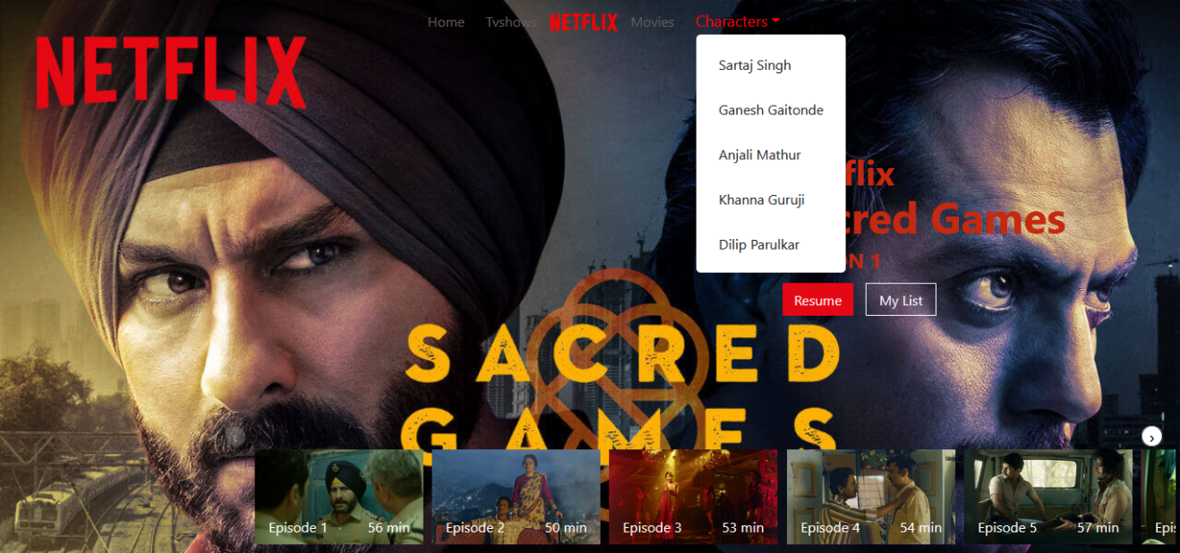

**Hero Section**:

1. Features a full-screen background image dynamically fetched from an external API.
2. Displays the series title and streaming platform dynamically fetched from an API.
3. Includes buttons for "Resume" and "My List."

**Output:** Images and Text which is comes from API.

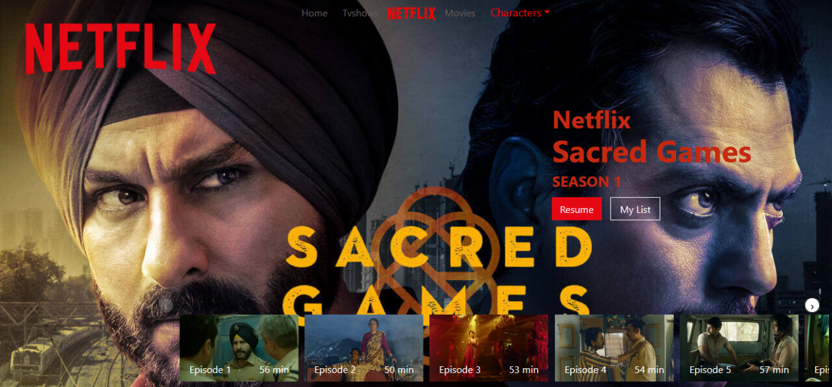

**Episode Carousel**:

1. Uses Owl Carousel to create a responsive and interactive carousel.
2. Each carousel item represents an episode with an image, title, and duration.

**Output:**

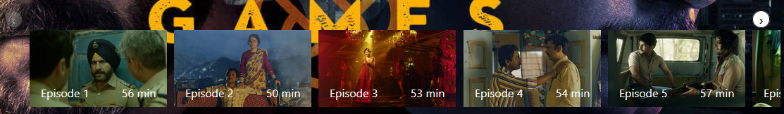

**Modal for Character Images**:

1. A modal window that appears when a character is selected from the dropdown menu
2. Displays the character's image and name dynamically.

**Output:**

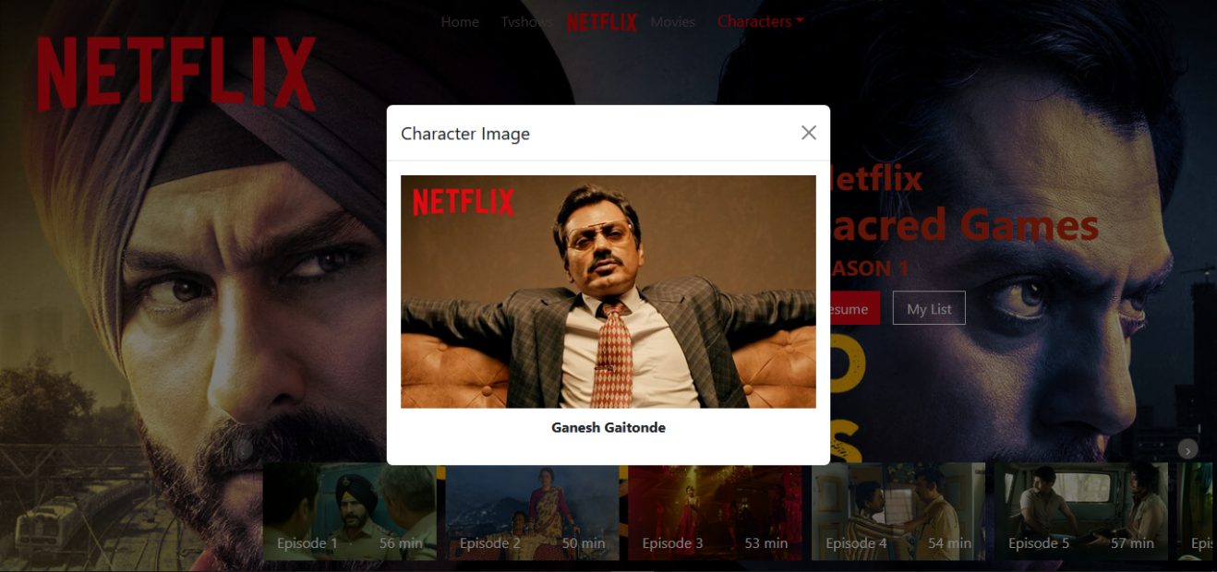

### Functionality

1. **Dynamic Content Fetching**:
2. Utilizes JavaScript to fetch data from an external API.
3. Updates the background image, series title, and streaming platform information based on the fetched data.
4. **Responsive Design**:
5. Ensures the web page is mobile-friendly and adapts to different screen sizes.
6. Uses Bootstrap for responsive layout and Owl Carousel for a responsive carousel.

**This Website is not fully Responsive Right now**

**User Interaction**:

1. Drop-down menu for character selection triggers a modal window.
2. Carousel allows users to navigate through different episodes.

### Technologies Used

* **HTML**: For structuring the web page.
* **CSS**: For styling the web page, including custom styles and Bootstrap.
* **JavaScript**: For dynamic content fetching and DOM manipulation.
* **Bootstrap**: For responsive design and layout.
* **Owl Carousel**: For creating the episode carousel.
* **jQuery**: For simplifying JavaScript operations and handling events.

### Goals

* Create an interactive and visually appealing front-end for displaying a OTT Series.
* Implement dynamic content fetching to keep the page up-to-date with external data.
* Ensure the web page is fully responsive and provides a seamless user experience across different devices.

**References**

**Tools and Websites**

1. VS Code code editor
2. Web Browsers Firefox, Chrome
3. Bootstrap Documentation
4. **Owl Carousel Documentation**
5. **API Usage**
6. W3 Schools, YouTube, ChatGPT

****Links****

1. ****Website Image Refernece :**** <https://repotech2edge.github.io/tasks/screen/screen.webp>
2. ****API :**** <https://repo-tech2edge.github.io/tasks/sample.json>

**My Personal Github Link**

<https://github.com/ShantanuVishwakarma67>